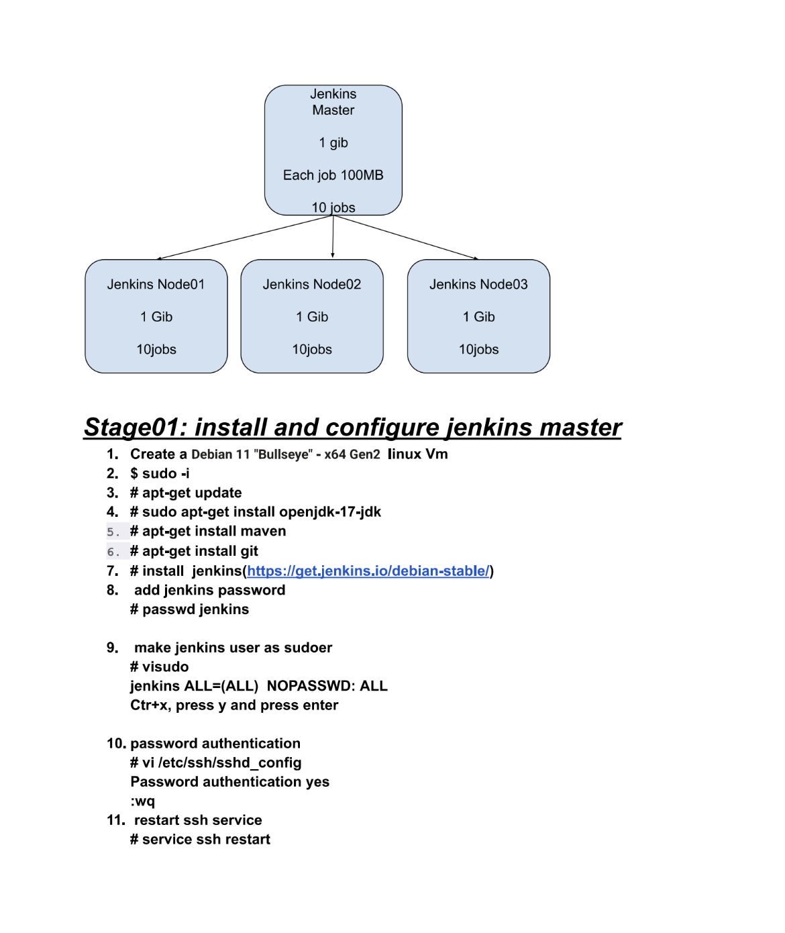

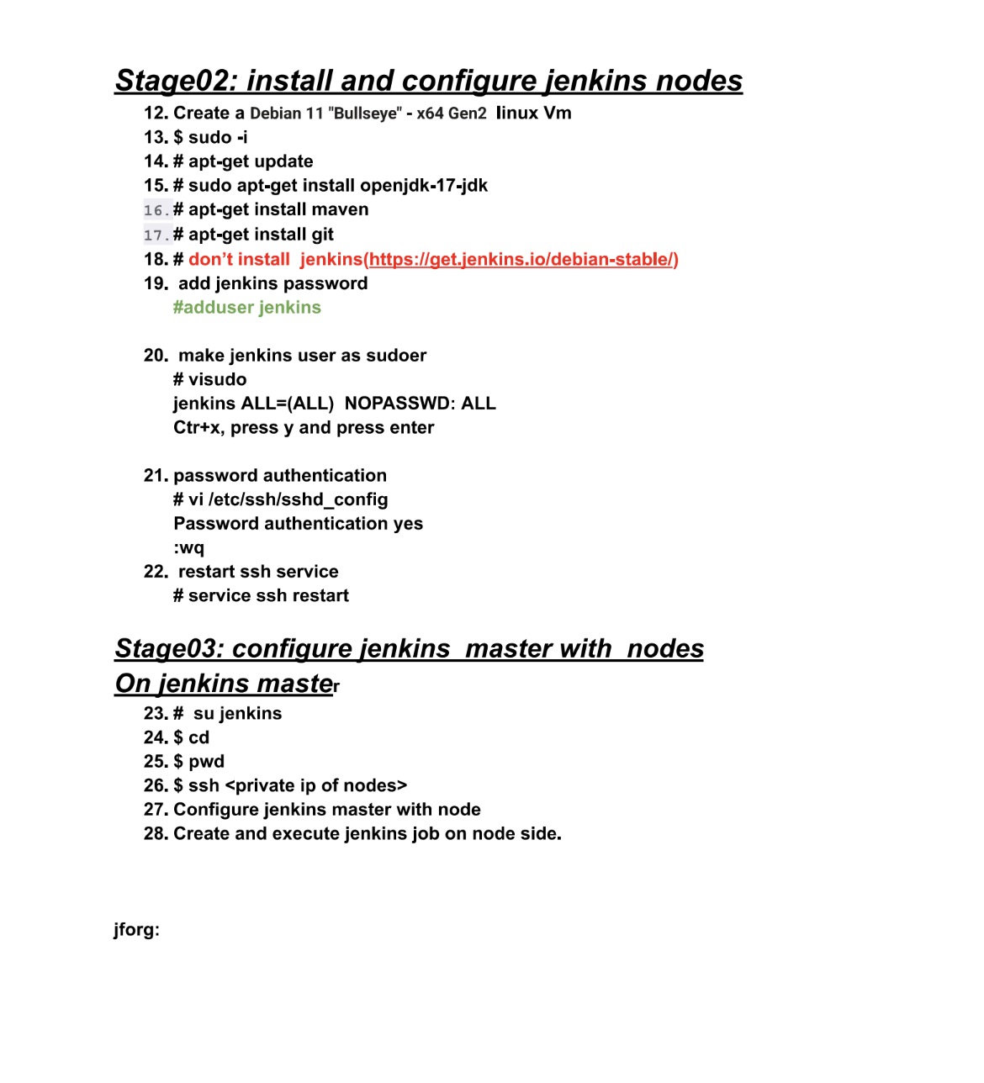

Jenkins Master-Agent Setup Guide

1. Architecture Overview
- Jenkins Master:
  - Coordinates builds.
  - Schedules jobs and assigns them to agents.
  - Handles the build pipeline and stores build results.
  - Minimum recommended: 4 GB RAM (you had 1 GB, which caused job execution memory issues).
- Jenkins Agent (Node):
  - Executes the build steps.
  - Can be distributed (scale horizontally).
  - Example Setup:
Master (4GB RAM)
|
|--- Agent Node 1 (1GB RAM)
|--- Agent Node 2 (1GB RAM)
|--- Agent Node 3 (1GB RAM)

2. EC2 Preparation (Ubuntu-based)
- Launch EC2 instances:
  - Master: t2.medium or higher (4 GB RAM minimum).
  - Agents: t2.micro/t2.small depending on load.
- Update and install tools:
#!/bin/bash

echo "🔄 Updating package list..."
sudo apt update -y

echo "📦 Installing OpenJDK 17..."
sudo apt install openjdk-17-jdk -y

echo "📦 Installing OpenJDK 17..."
sudo apt install openjdk-8-jdk

echo "📦 Installing Maven (optional)..."
sudo apt install maven -y

echo "📦 Installing 'tree' utility (optional)..."
sudo apt install tree -y

echo "🔑 Adding Jenkins repository key..."
sudo mkdir -p /usr/share/keyrings
curl -fsSL https://pkg.jenkins.io/debian-stable/jenkins.io-2023.key | sudo tee /usr/share/keyrings/jenkins-keyring.asc > /dev/null

echo "📦 Adding Jenkins source list..."
echo "deb [signed-by=/usr/share/keyrings/jenkins-keyring.asc] https://pkg.jenkins.io/debian-stable binary/" | sudo tee /etc/apt/sources.list.d/jenkins.list > /dev/null

echo "🔄 Updating package list again..."
sudo apt update -y

echo "📦 Installing Jenkins..."
sudo apt install jenkins -y

echo "🚀 Starting and enabling Jenkins service..."
sudo systemctl start jenkins
sudo systemctl enable jenkins

echo "🛡️ Configuring UFW firewall rules..."
sudo ufw allow 8080
sudo ufw allow OpenSSH
sudo ufw --force enable

echo "✅ Jenkins installation complete!"
echo "🌐 Access Jenkins at: http://<your-server-ip>:8080"
echo "🔐 Initial Admin Password:"
sudo cat /var/lib/jenkins/secrets/initialAdminPassword

✅ Jenkins installation complete!
🌐 Access Jenkins at: http://<your-server-ip>:8080
🔐 Initial Admin Password:
cb8549017e714bb9be9beb8a0ca01c6e

4. User and SSH Configuration
- Add user jenkins and set password:
sudo adduser jenkins
sudo passwd jenkins
- Edit /etc/ssh/sshd_config:
PasswordAuthentication yes

- Then restart SSH:
sudo service ssh restart
- Setup passwordless SSH from master to nodes:
su - jenkins
ssh-keygen
ssh-copy-id jenkins@<agent_private_ip>
- Configure sudo access (visudo):
jenkins ALL=(ALL:ALL) NOPASSWD:ALL

5. Connect Nodes from Jenkins UI
- Jenkins Dashboard → Manage Jenkins → Manage Nodes and Clouds → New Node
  - Name: node-1
  - Remote root directory: /home/jenkins
  - Usage: Use this node as much as possible
  - Launch method: Launch agents via SSH
    - Host: Private IP of agent
    - Credentials: Jenkins user and password

6. Labeling and Job Binding
- Assign labels like myjenkinsnode01 to each node.
- In job → Configure → Restrict where this project can be run → Label expression.

7. Verify Job Execution
- Execute env or pwd in Jenkins jobs to verify whether jobs are running on the node or master.
- Ensure that job workspaces are being created in /home/jenkins/workspace.

Best Practices
- Avoid executing heavy jobs on the master. Reserve master for coordination.
- Use dedicated labels for job targeting and scaling.
- Monitor memory/CPU of each node using htop or Jenkins monitoring plugins.
- Backup Jenkins config and secrets regularly.

Based on your output from /etc/passwd, here’s a breakdown of the users on your Jenkins server, with focus on which ones are system vs. human accounts, and their purpose:

✅ Human/Service Users Summary

Username | UID | Purpose | Login Shell
root | 0 | Superuser | /bin/bash
jenkinsuser | 1000 | Likely manually created user for admin or Jenkins testing | /bin/bash
jenkins | 114 | Jenkins service account (used by Jenkins process) | /bin/bash

⚙️ System/Service Users (Non-Login)
These are used by the system or background services (e.g., _chrony, lxd, etc.) and cannot log in.

Username | Shell | Role / Service
_chrony | /usr/sbin/nologin | Chrony NTP service
lxd | /bin/false | LXD container management daemon
sshd | /usr/sbin/nologin | OpenSSH server
systemd-* | /usr/sbin/nologin | System services (network, resolve, etc.)
Many others | /usr/sbin/nologin or /bin/false | For secure background operation

🧠 Key Observations
- ✅ jenkins: Jenkins creates this user by default. It owns the Jenkins home directory (/var/lib/jenkins) and runs the Jenkins service.
- ✅ jenkinsuser: You or someone created this manually. This is a real login user (/home/jenkinsuser) and can be used for SSH or manual administration.
- 🔐 System accounts like _chrony, sshd, and lxd should not be deleted — they support critical services.

🛠️ Tips
- To check if a user has shell access (i.e., can login):
grep '/bin/bash' /etc/passwd
- To check current user:
whoami
- To check who’s logged in:
who

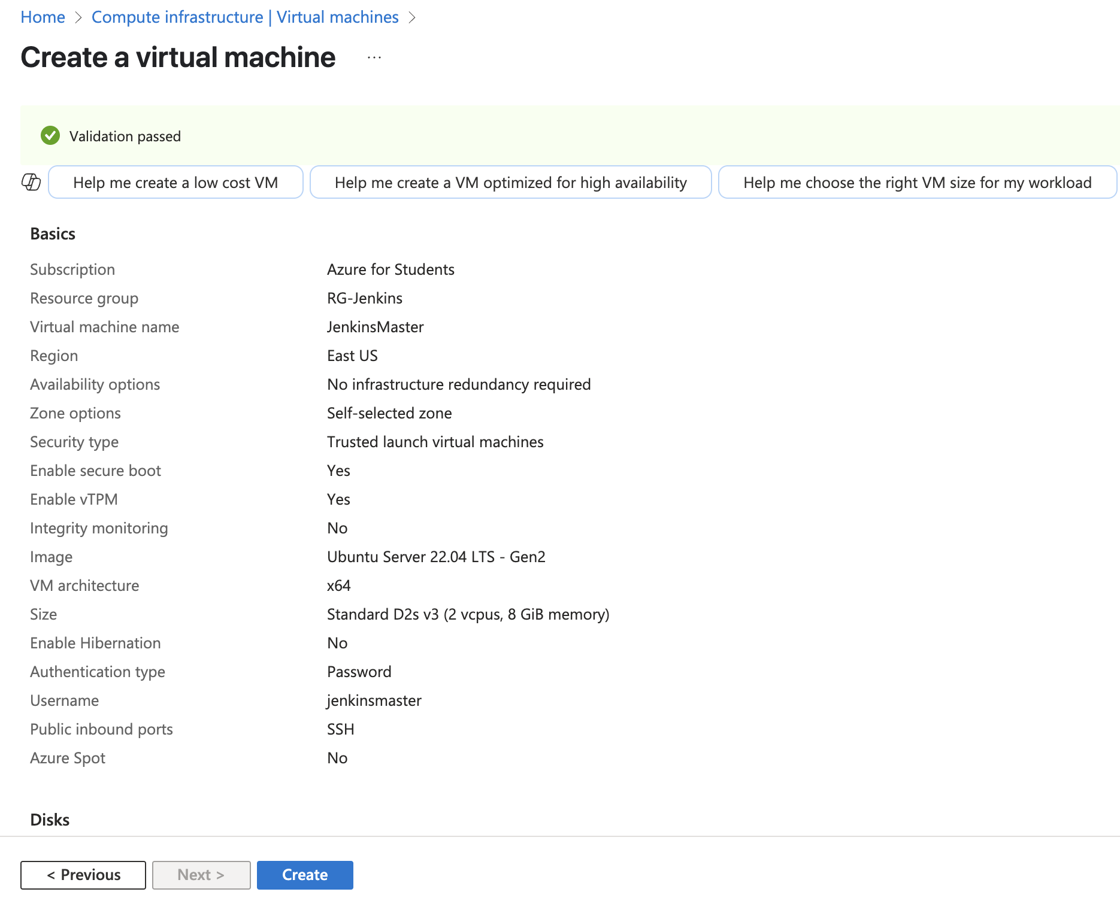

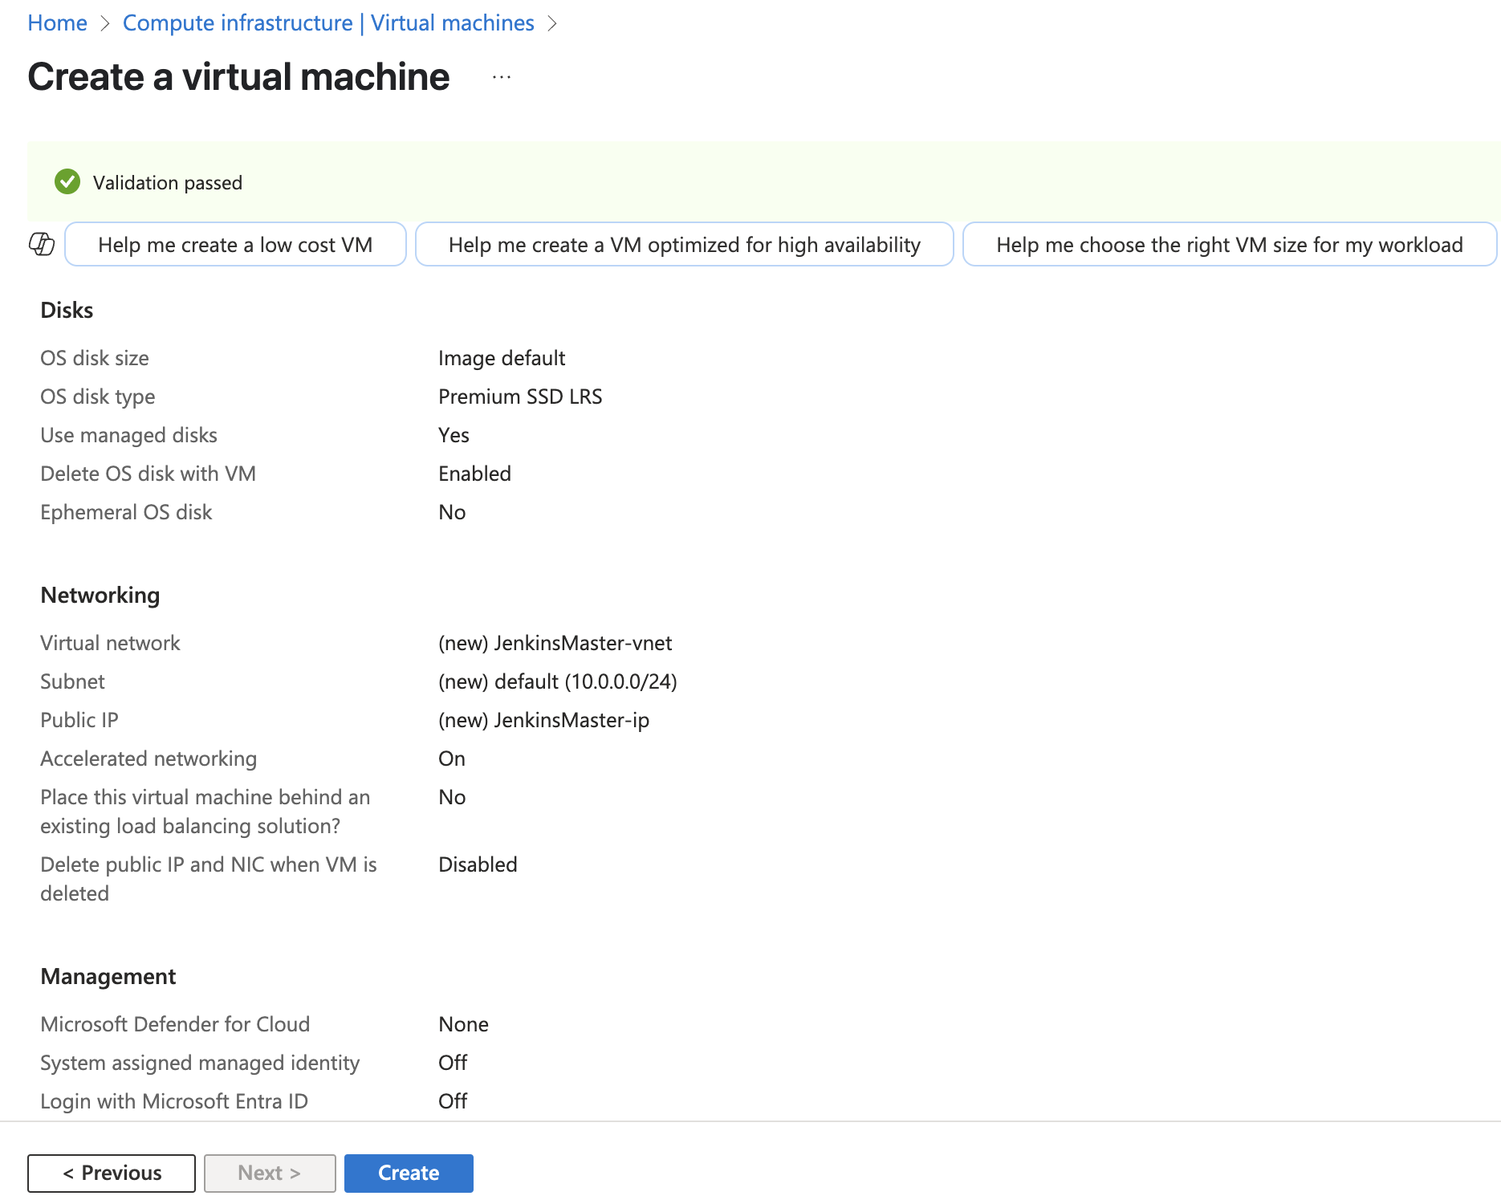

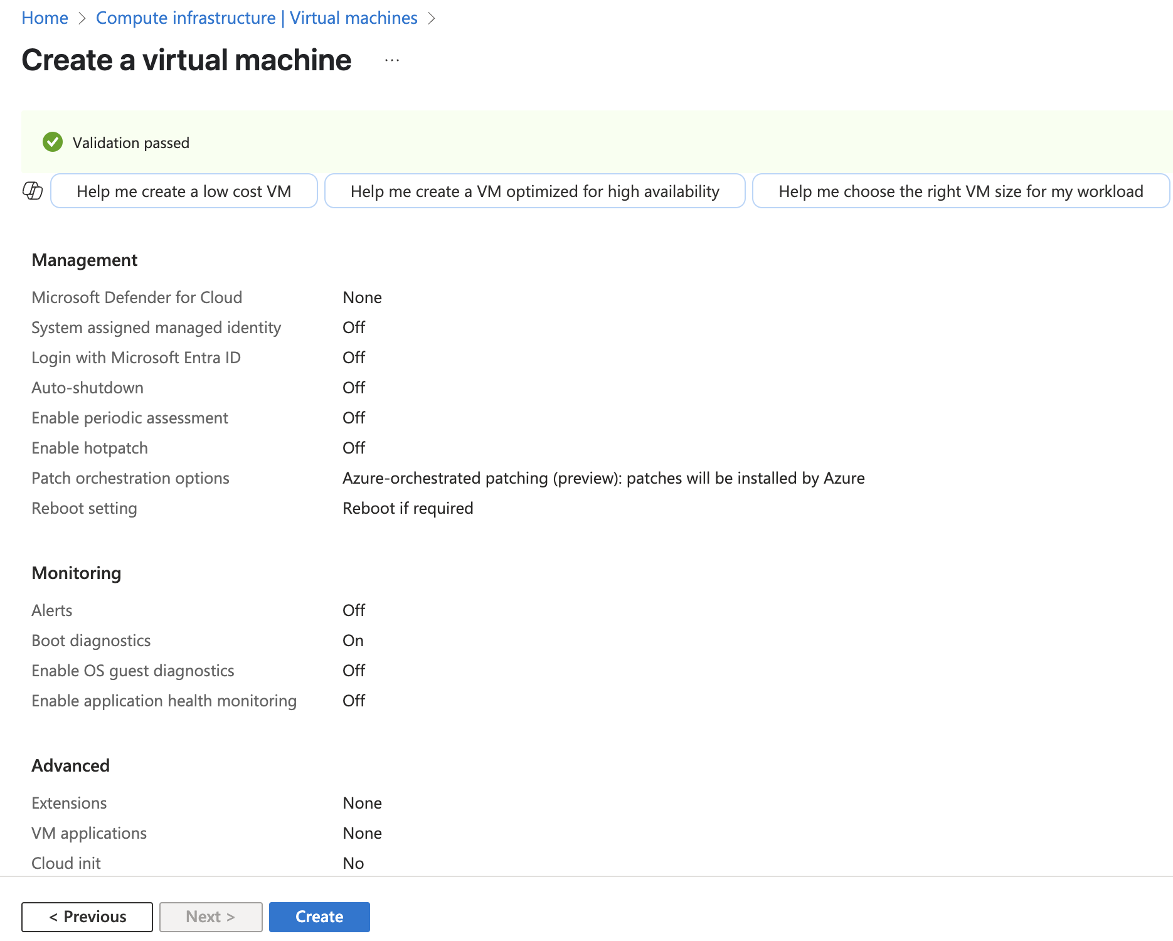

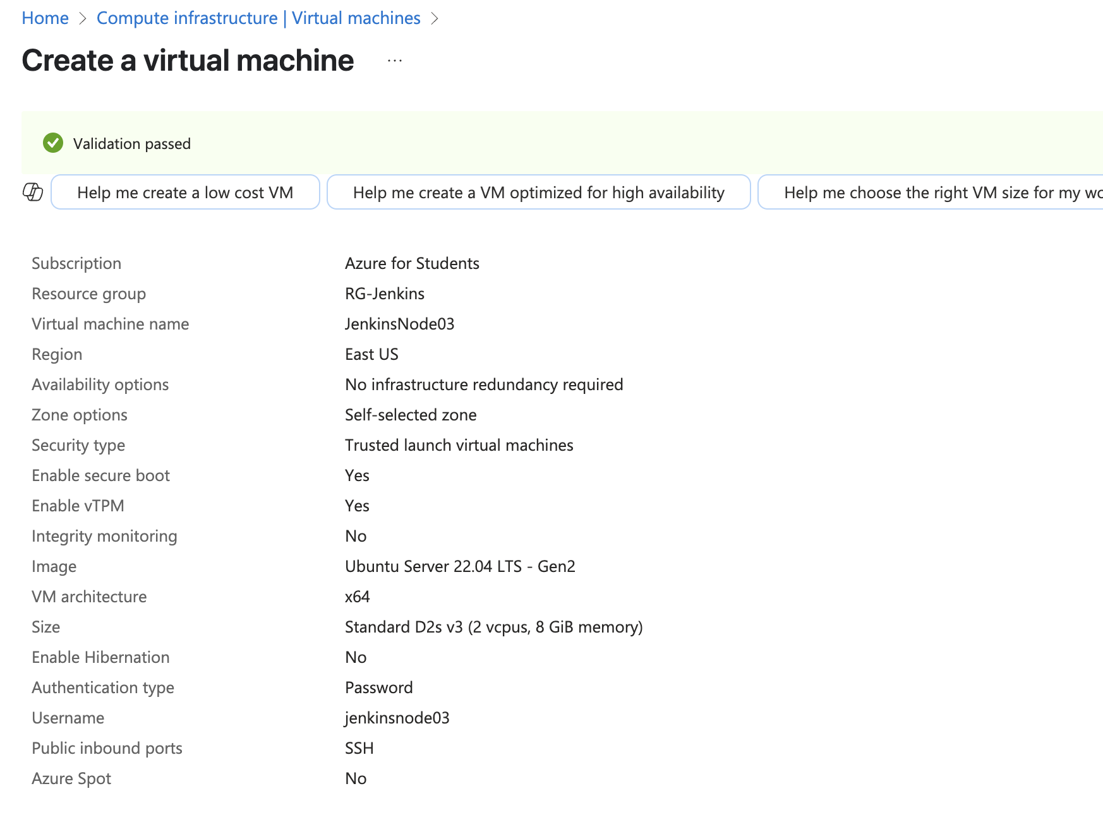

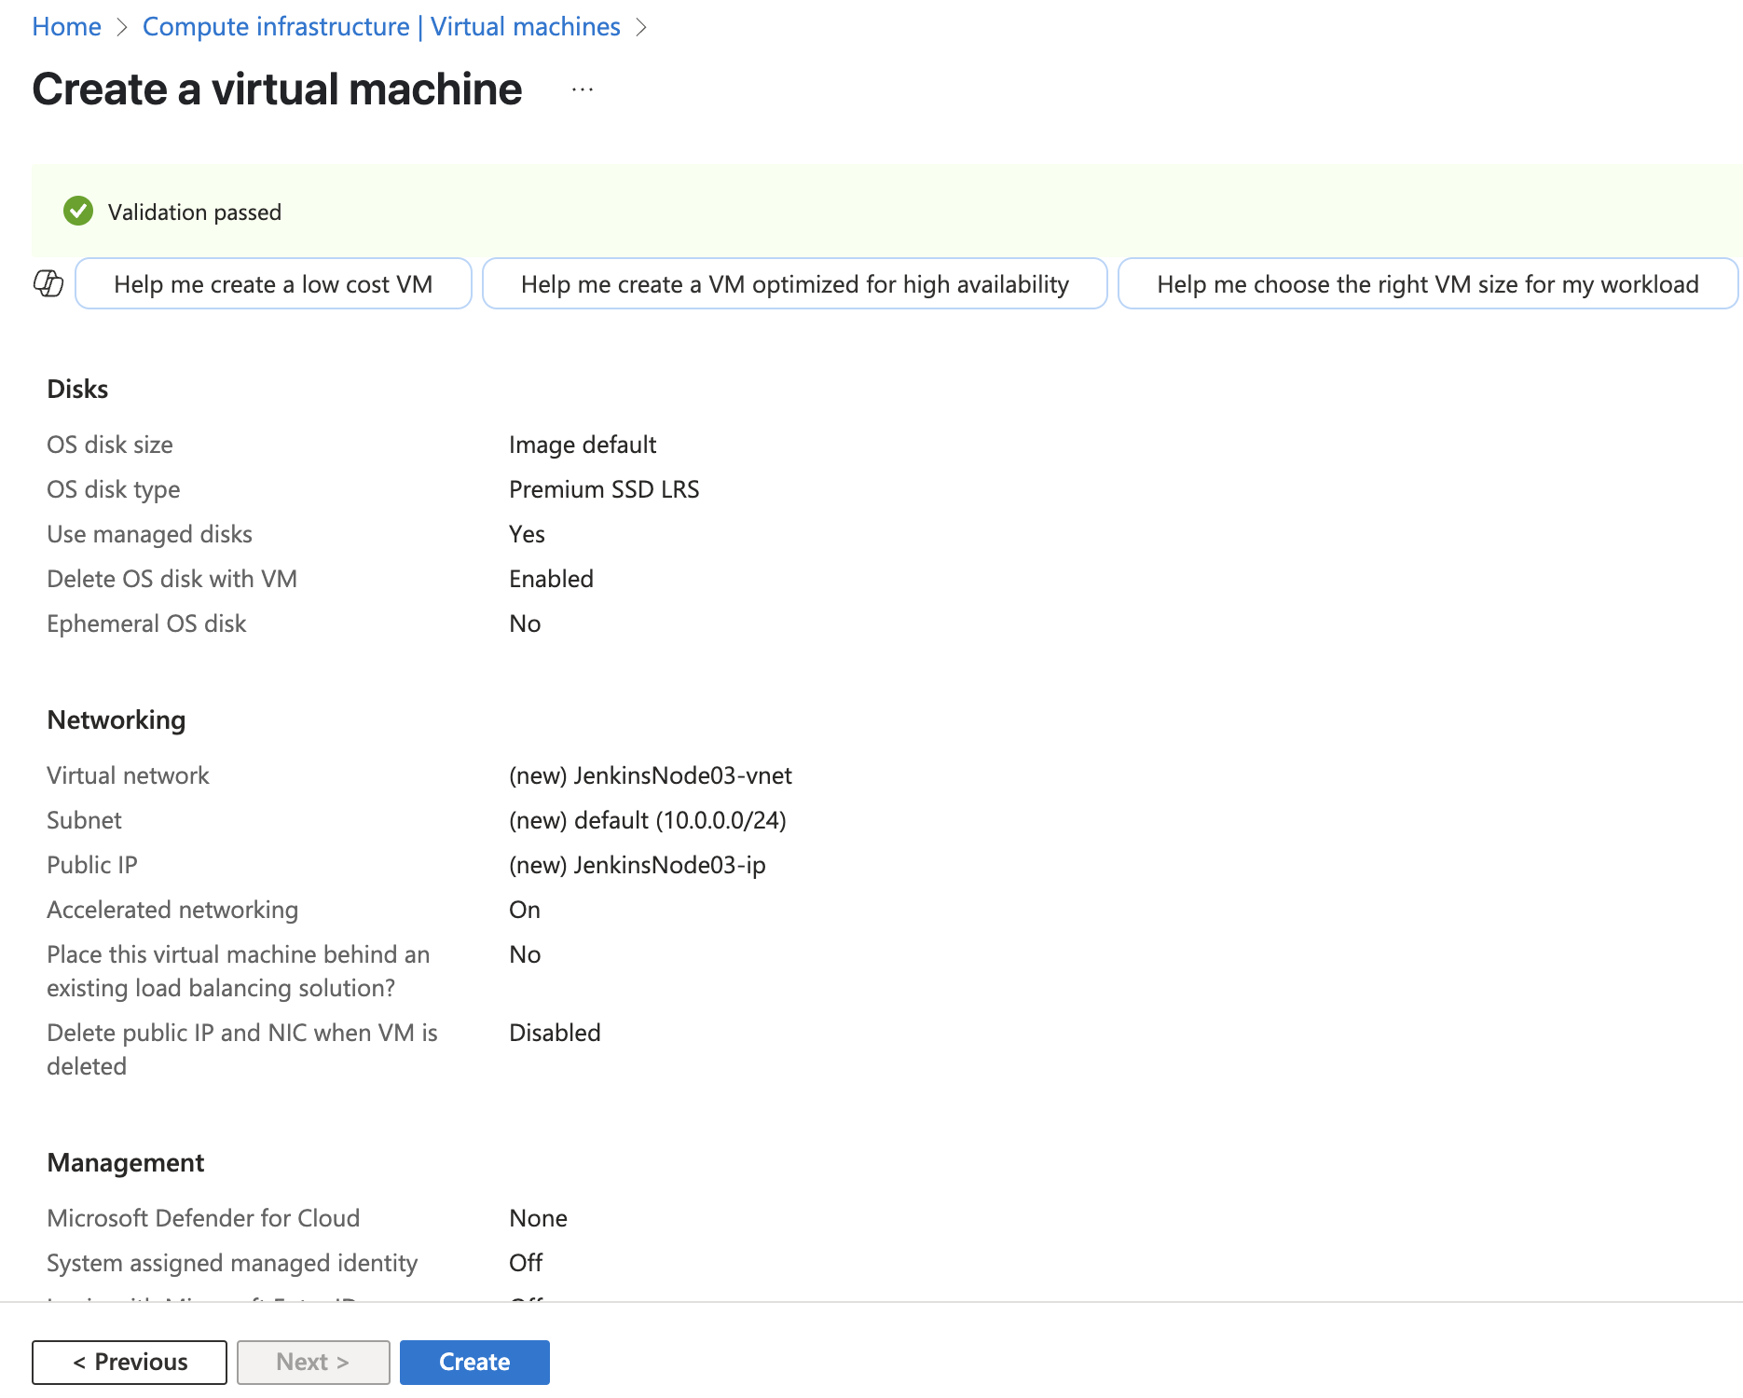

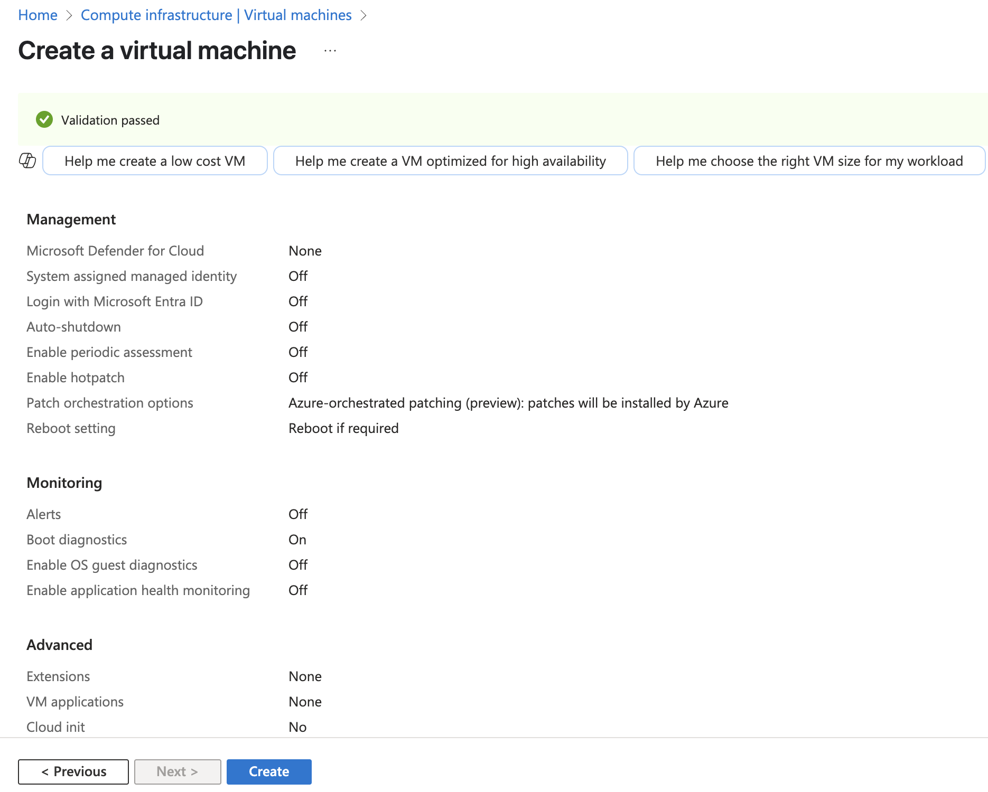

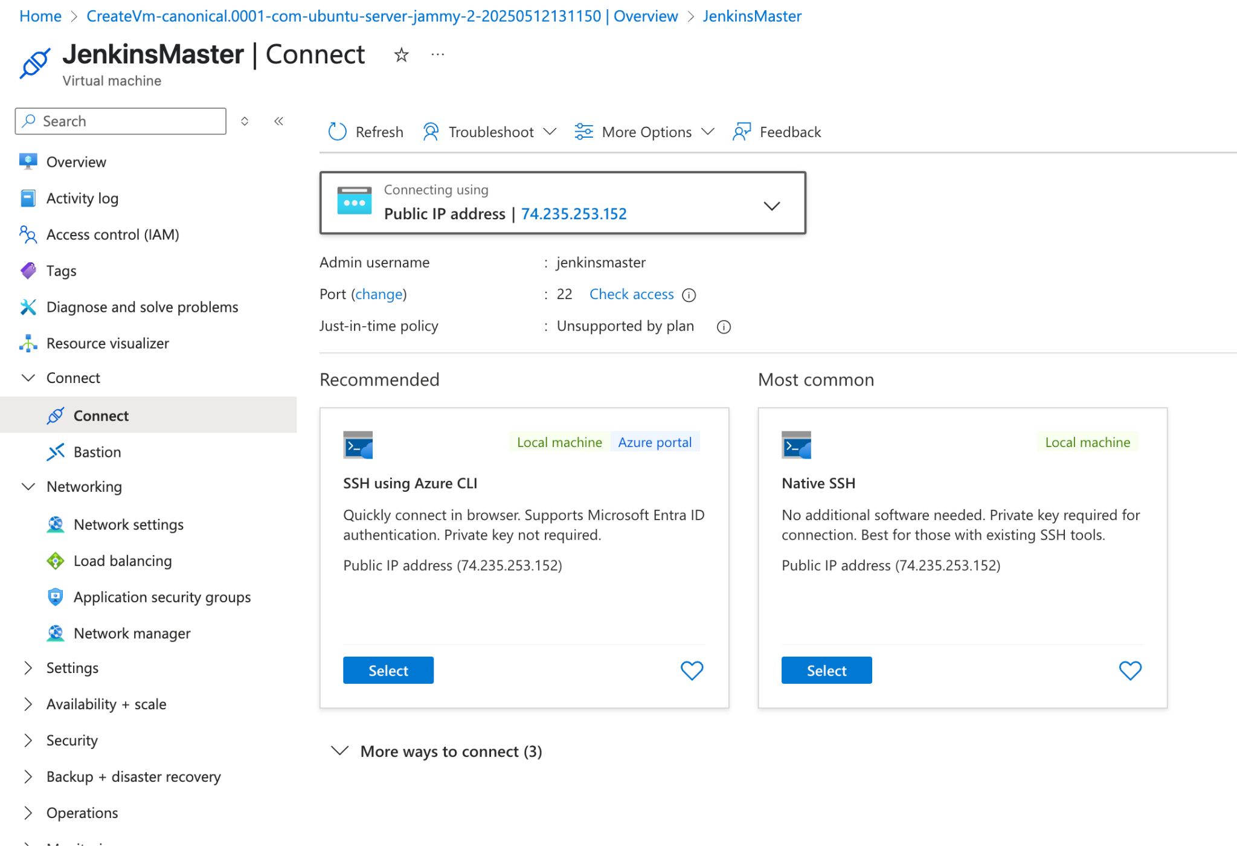

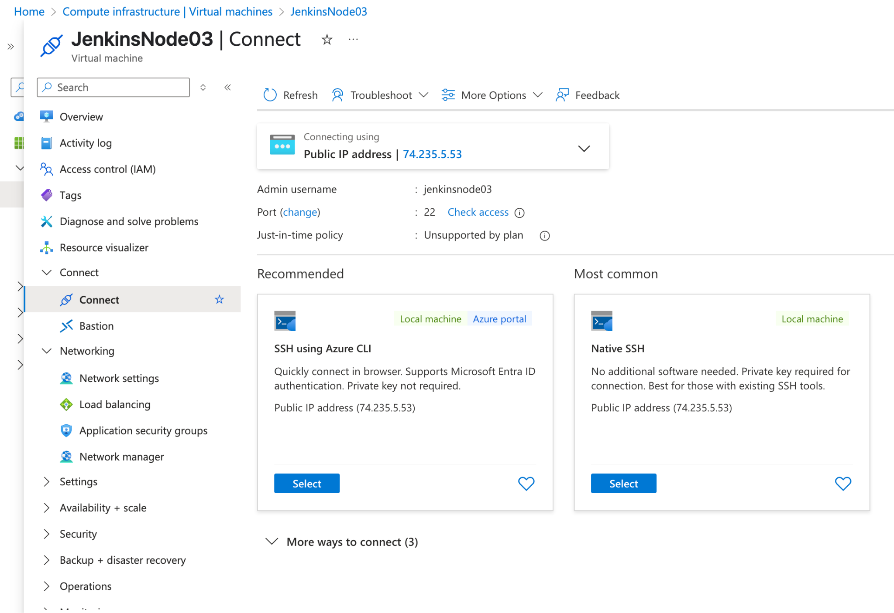

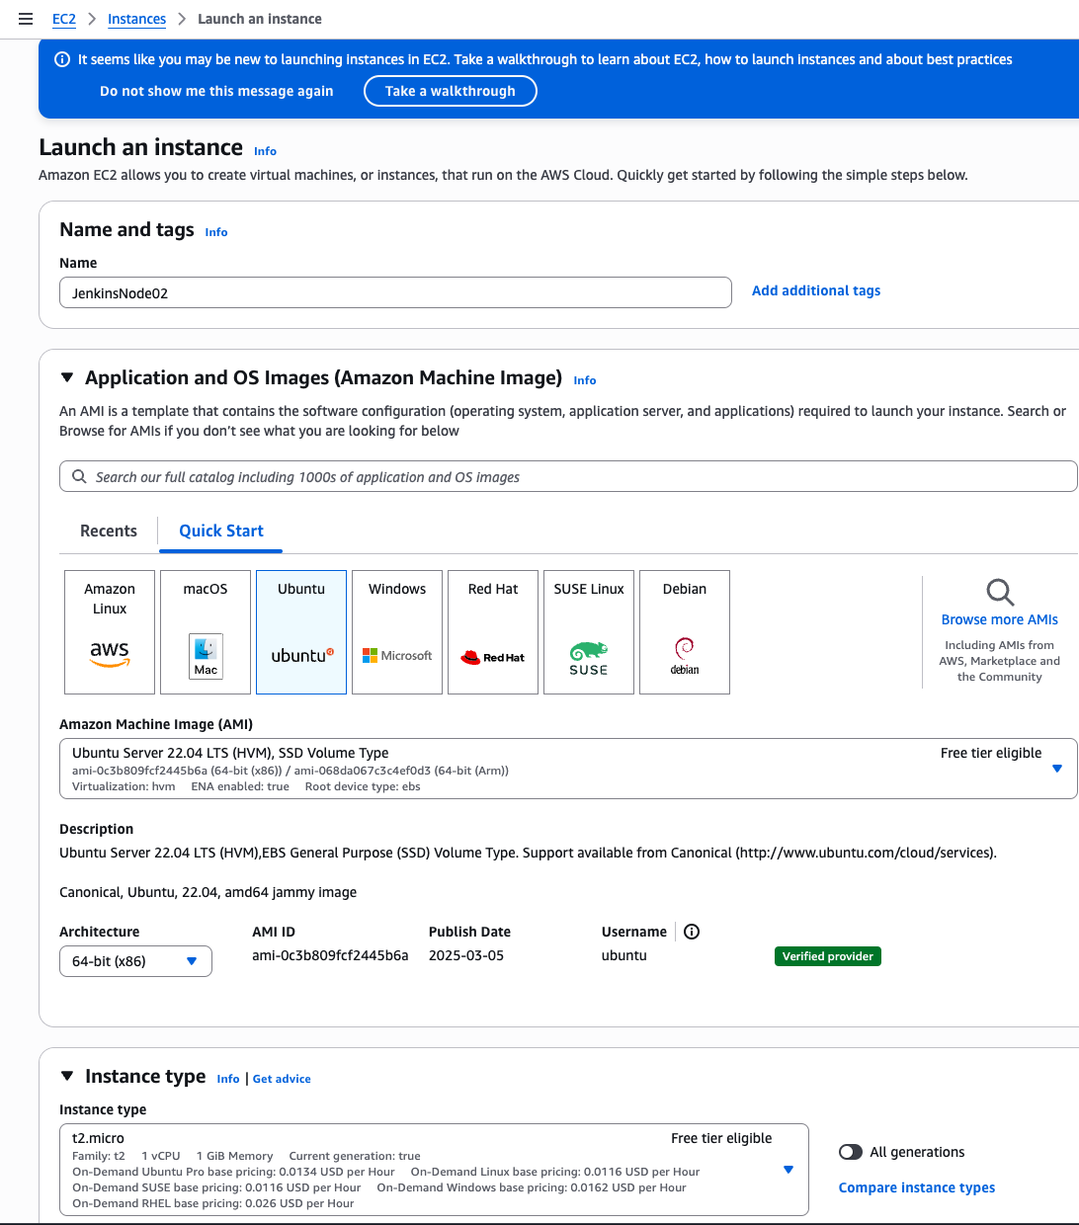

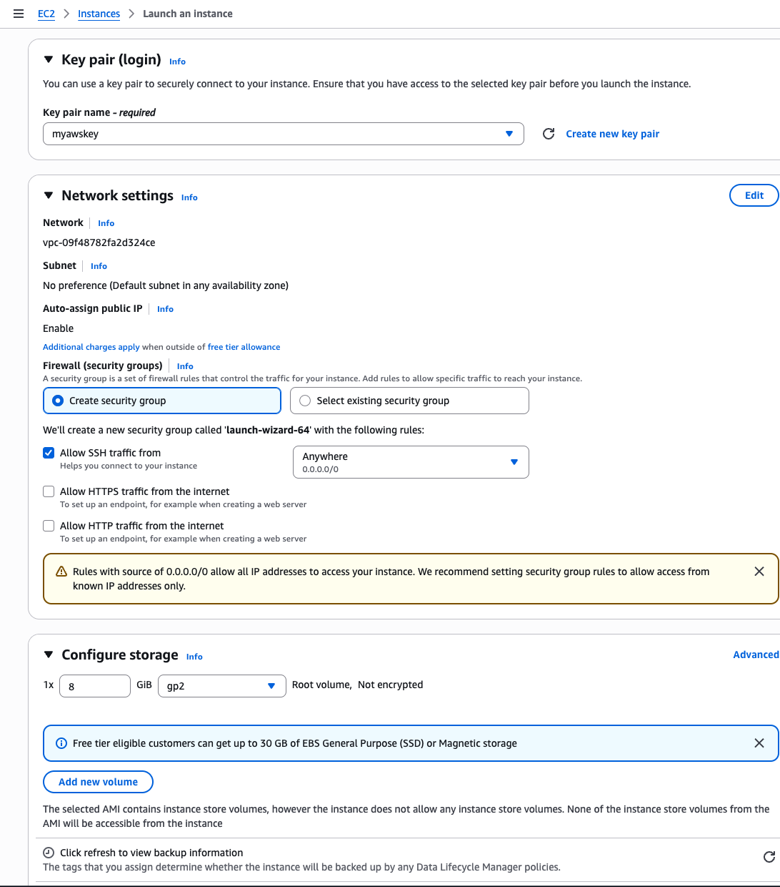

JenkinsMaster:
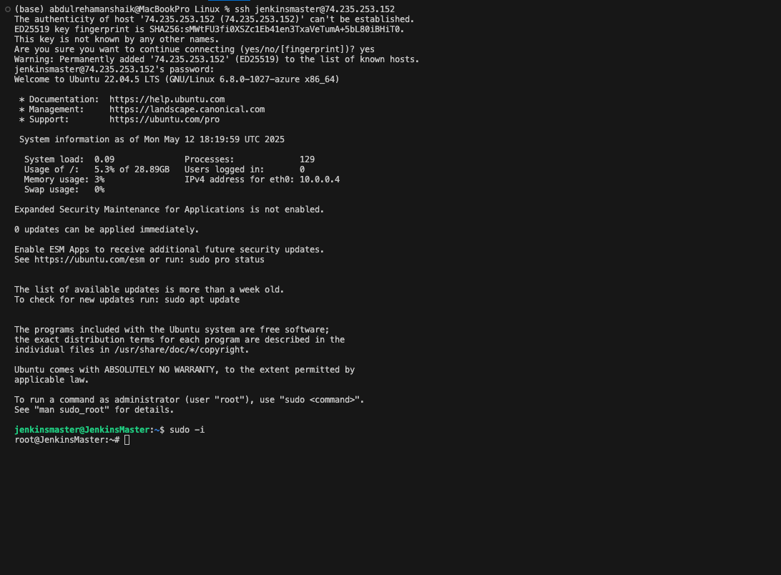

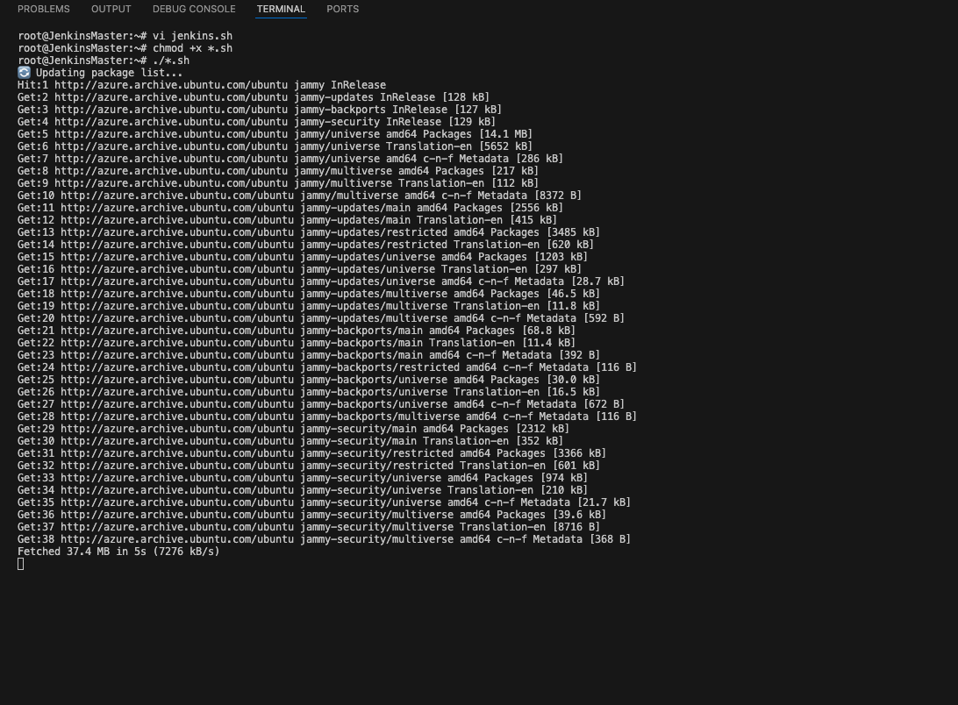

✅ Jenkins installation complete!
🌐 Access Jenkins at: http://<your-server-ip>:8080
🔐 Initial Admin Password:
f0ae3cdb952c4ec89f6d6b6b0e97f133
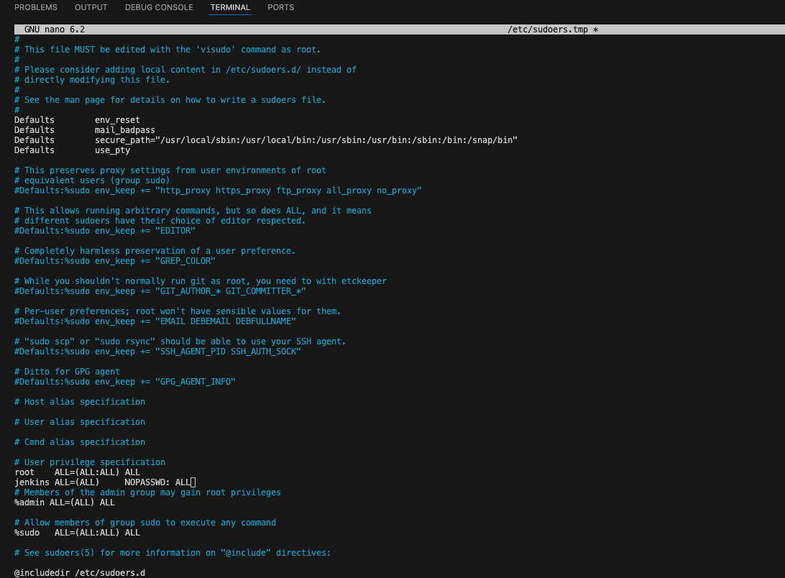

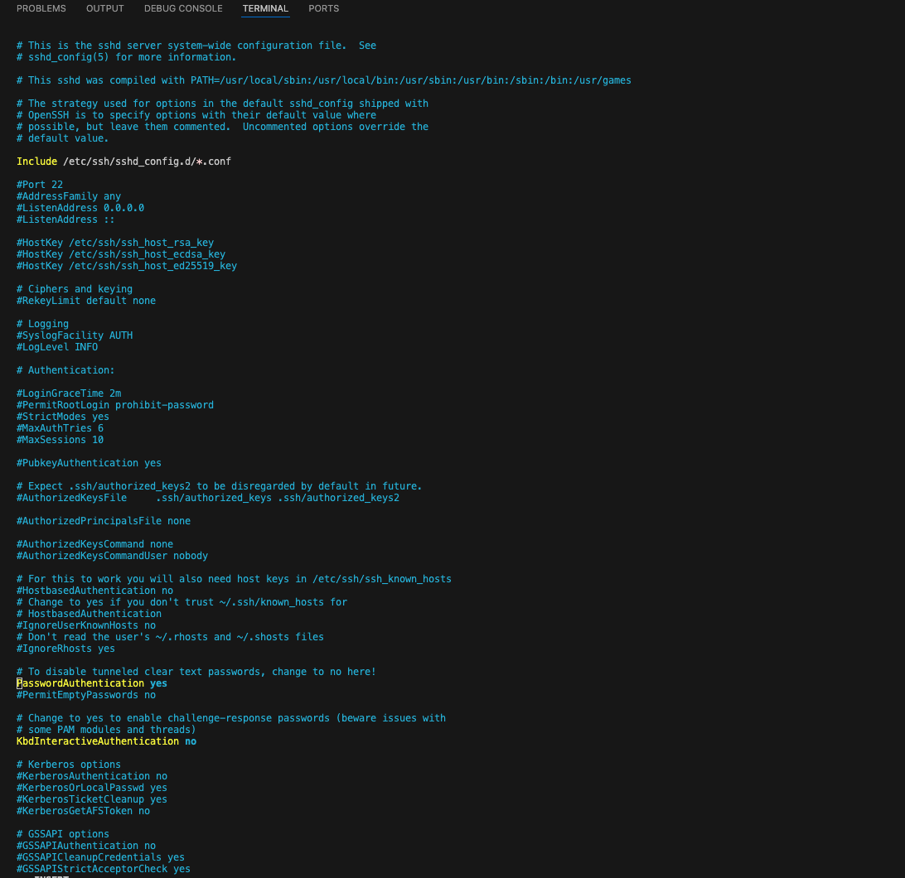

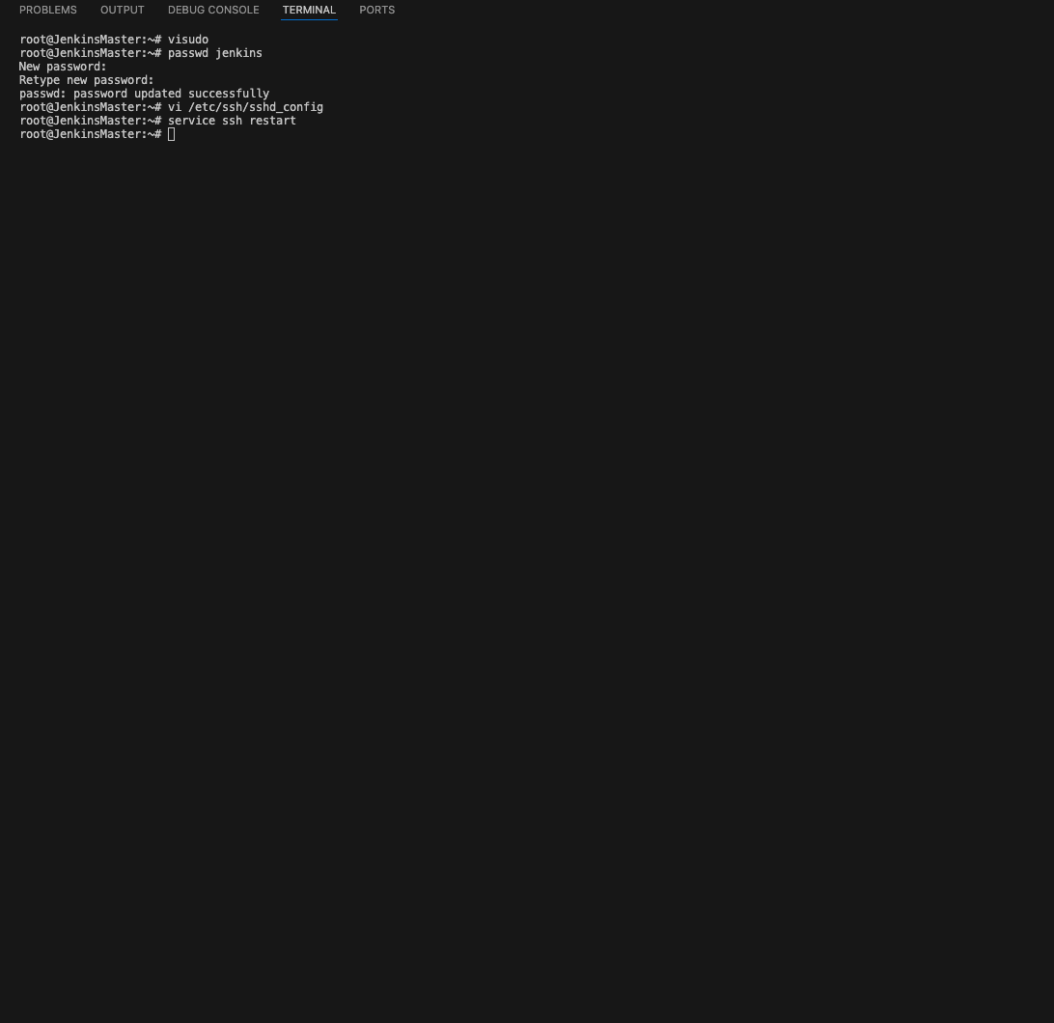

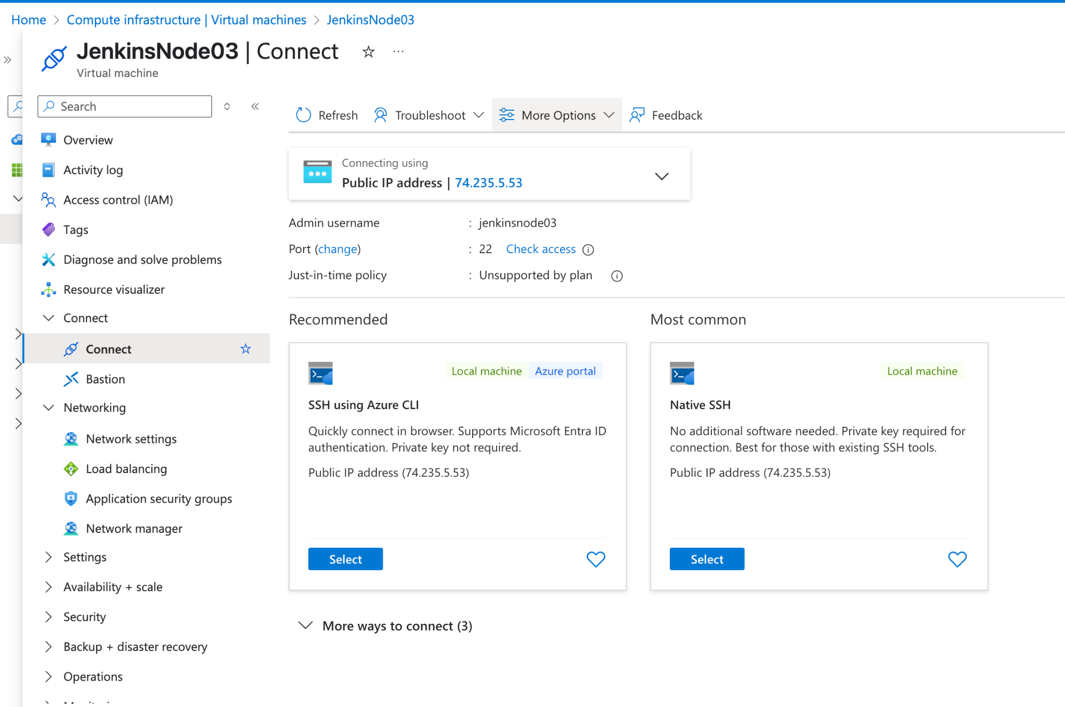

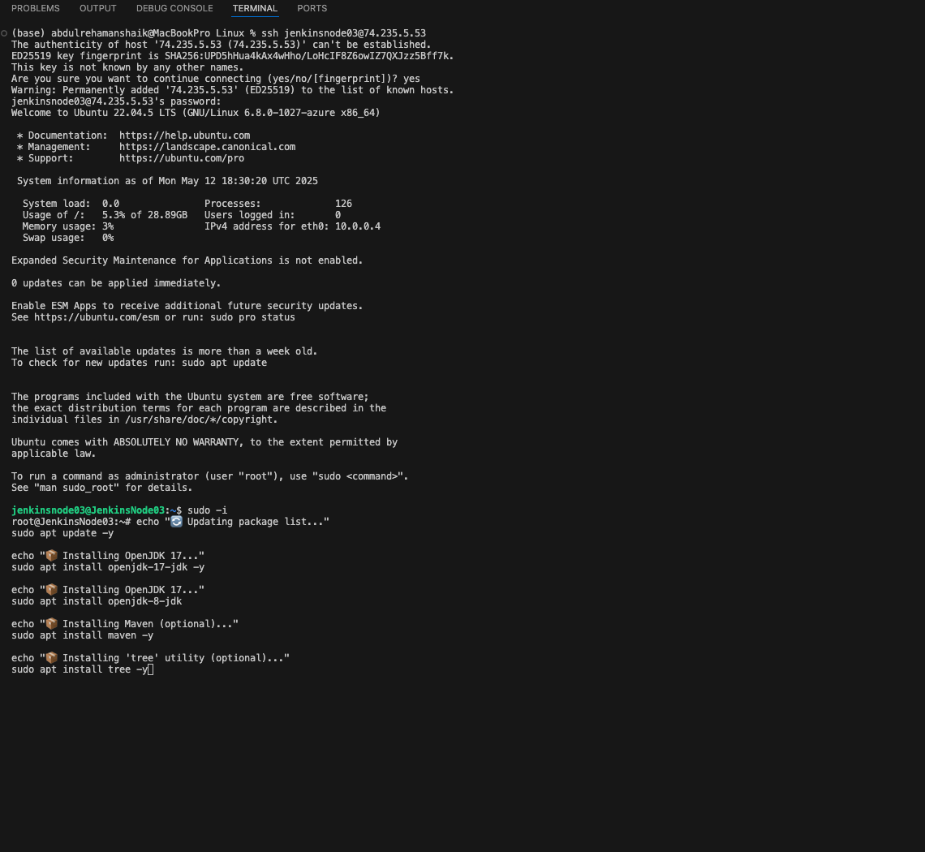

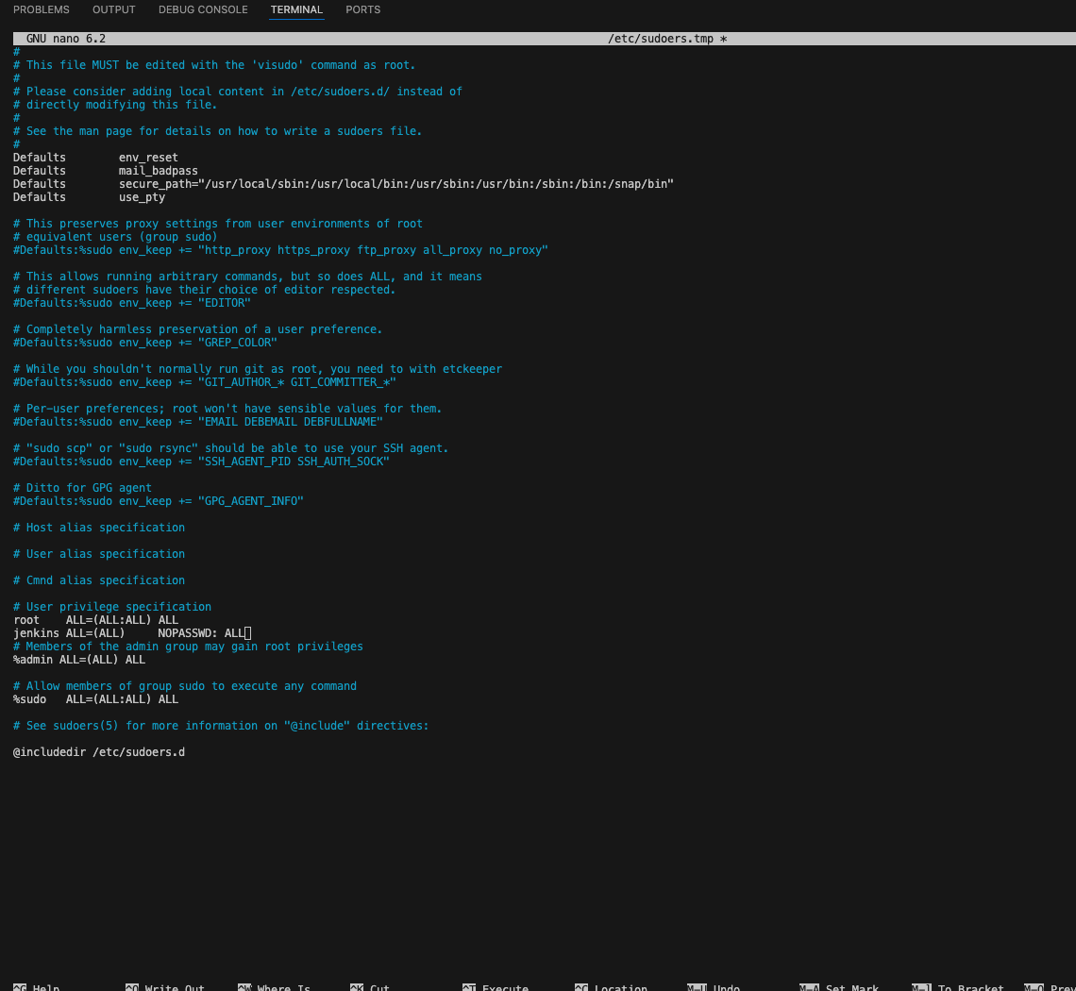

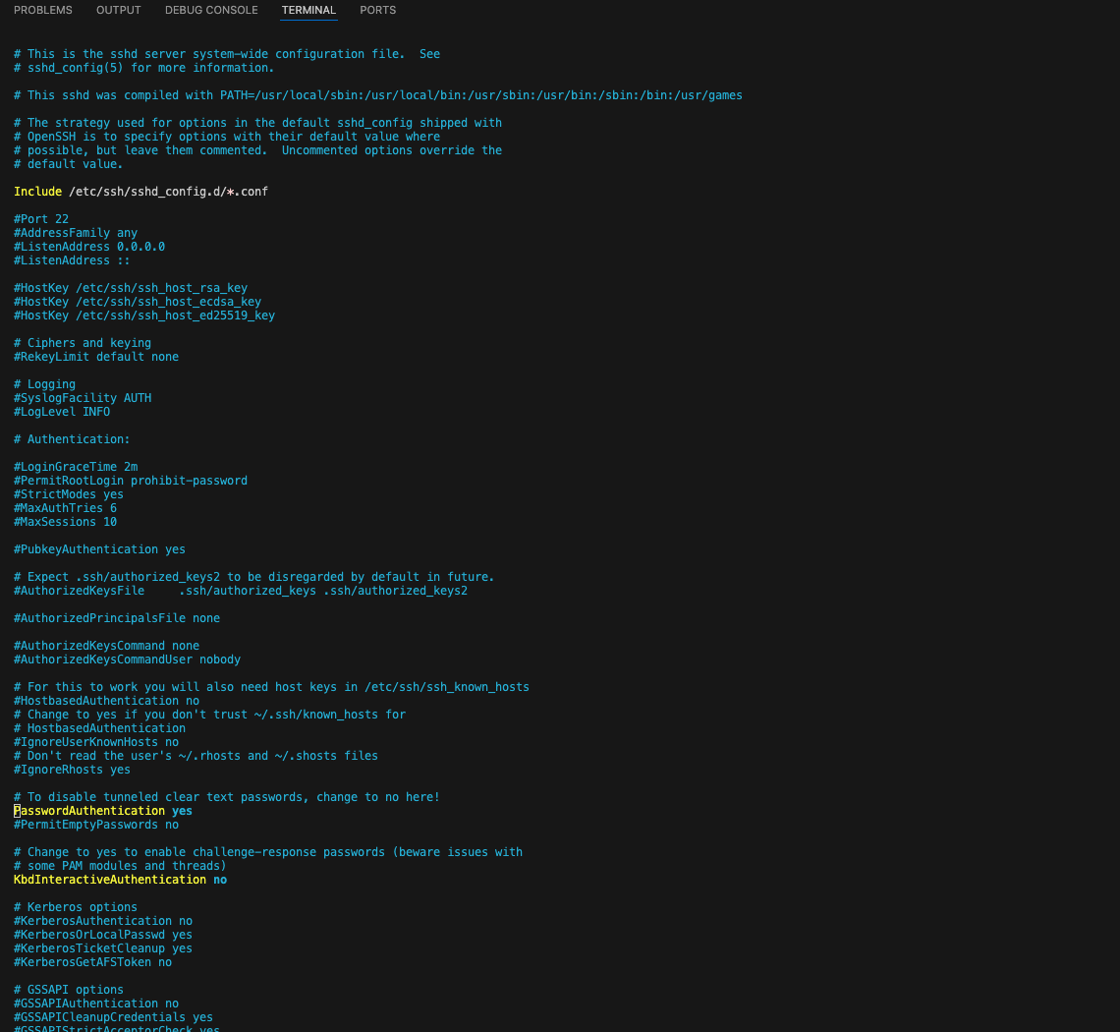

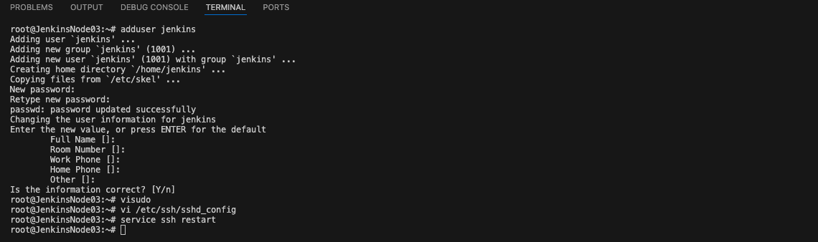

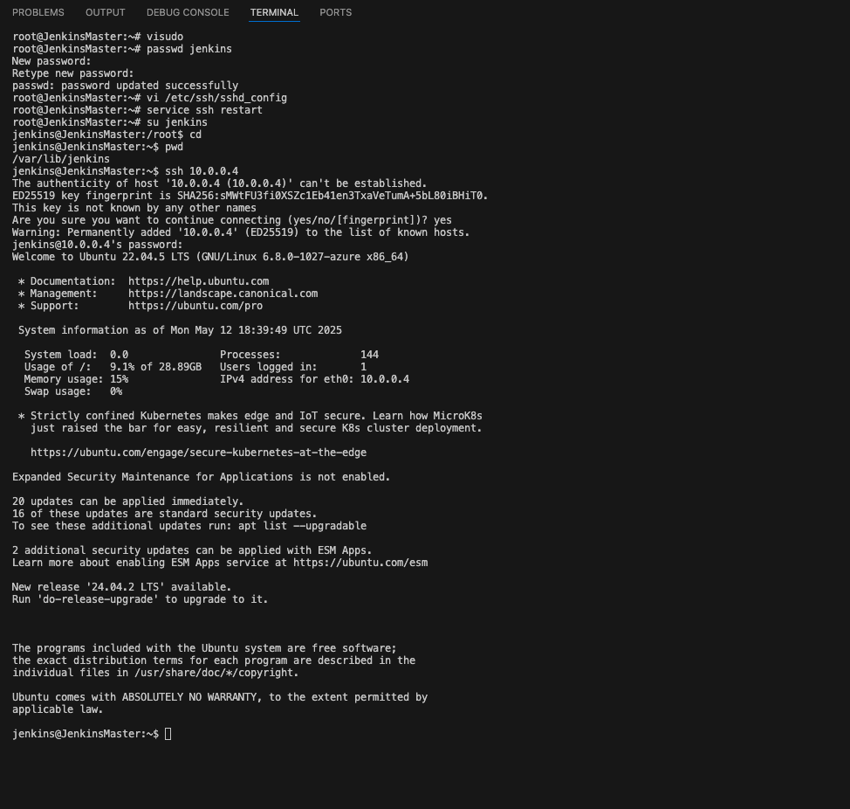

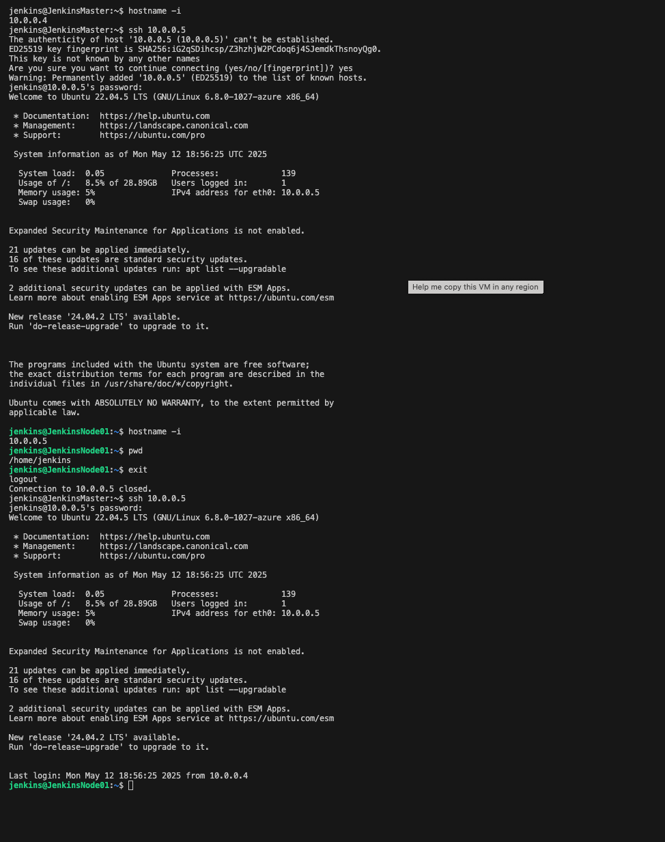

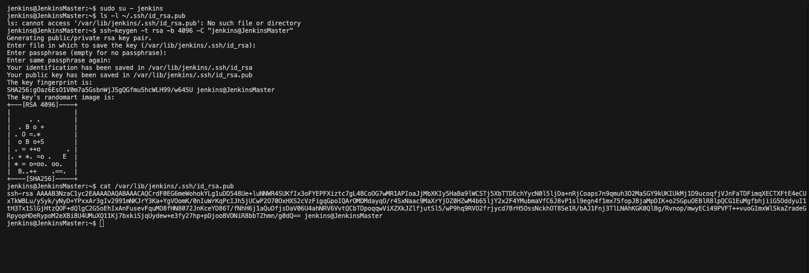

You're trying to SSH from your JenkinsMaster (Azure) to JenkinsNode02 (AWS) as user jenkins, but getting:
Permission denied (publickey)

This error means:
- The SSH public key of user jenkins on the JenkinsMaster has not been added to the ~/.ssh/authorized_keys file of user jenkins on the JenkinsNode02 (AWS).

✅ Step-by-Step Fix: Setup SSH Access from Azure JenkinsMaster → AWS JenkinsNode

🔐 1. On JenkinsMaster (Azure):
Check for SSH key:
sudo su - jenkins
ls -l ~/.ssh/id_rsa.pub

If it doesn’t exist, generate one:
ssh-keygen -t rsa -b 4096 -C "jenkins@JenkinsMaster"

Just press enter for defaults (no passphrase).
Copy the public key:
cat ~/.ssh/id_rsa.pub

🧩 2. On JenkinsNode02 (AWS):
Login with a working user (e.g., ec2-user, ubuntu, or root) using your existing AWS key pair:
ssh -i your-aws-key.pem ec2-user@18.188.135.135

Then:
Create the jenkins user (if not exists):
sudo useradd -m -s /bin/bash jenkins

Create .ssh directory:
sudo mkdir -p /home/jenkins/.ssh
sudo nano /home/jenkins/.ssh/authorized_keys

- Paste the public key you copied from Azure JenkinsMaster.
Set permissions:
sudo chown -R jenkins:jenkins /home/jenkins/.ssh
sudo chmod 700 /home/jenkins/.ssh
sudo chmod 600 /home/jenkins/.ssh/authorized_keys

✅ 3. Test the SSH from Azure JenkinsMaster
Back on your Azure master:
ssh jenkins@18.188.135.135

It should log in without password.

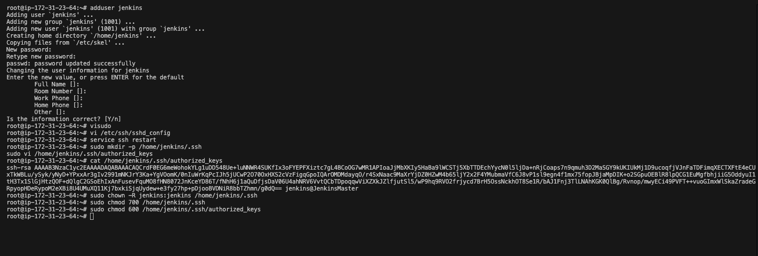

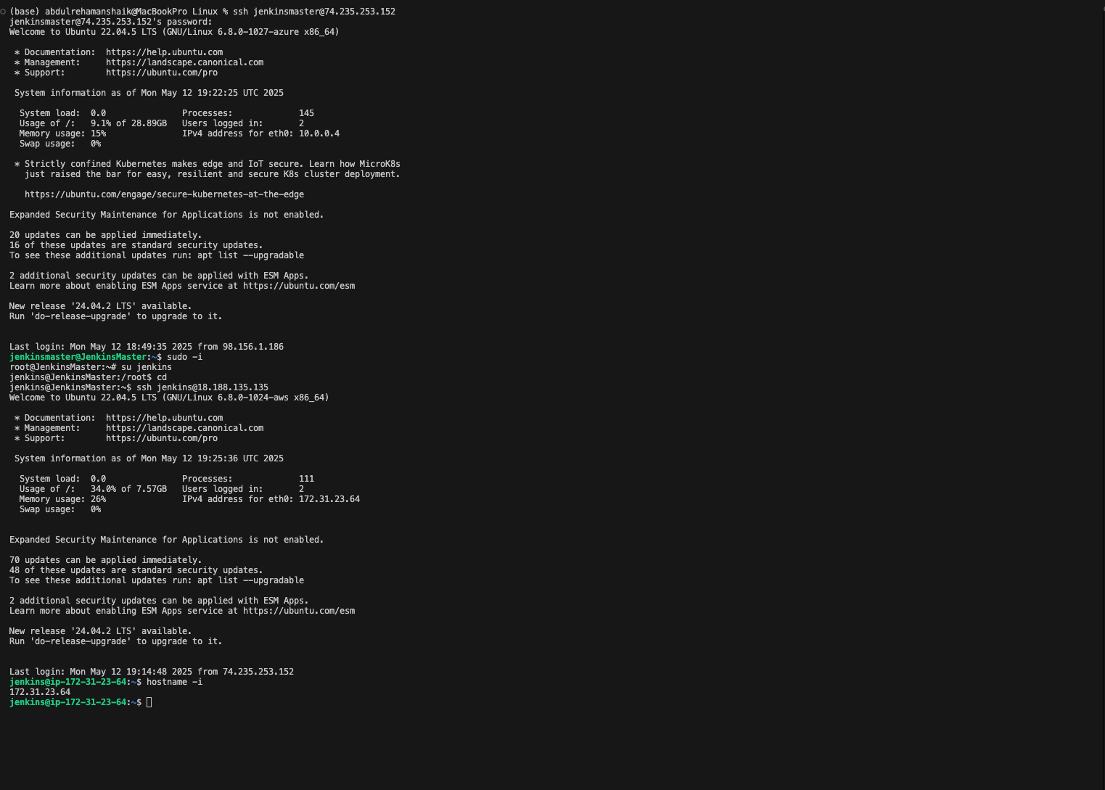

(base) abdulrehamanshaik@MacBookPro Linux % ssh jenkinsmaster@74.235.253.152
jenkinsmaster@74.235.253.152's password:
Welcome to Ubuntu 22.04.5 LTS (GNU/Linux 6.8.0-1027-azure x86_64)

* Documentation: https://help.ubuntu.com
* Management: https://landscape.canonical.com
* Support: https://ubuntu.com/pro

System information as of Mon May 12 19:22:25 UTC 2025

System load: 0.0 Processes: 145
Usage of /: 9.1% of 28.89GB Users logged in: 2
Memory usage: 15% IPv4 address for eth0: 10.0.0.4
Swap usage: 0%

* Strictly confined Kubernetes makes edge and IoT secure. Learn how MicroK8s
just raised the bar for easy, resilient and secure K8s cluster deployment.

https://ubuntu.com/engage/secure-kubernetes-at-the-edge

Expanded Security Maintenance for Applications is not enabled.

20 updates can be applied immediately.
16 of these updates are standard security updates.
To see these additional updates run: apt list --upgradable

2 additional security updates can be applied with ESM Apps.
Learn more about enabling ESM Apps service at https://ubuntu.com/esm

New release '24.04.2 LTS' available.
Run 'do-release-upgrade' to upgrade to it.

Last login: Mon May 12 18:49:35 2025 from 98.156.1.186
jenkinsmaster@JenkinsMaster:~$ sudo -i
root@JenkinsMaster:~# su jenkins
jenkins@JenkinsMaster:/root$ cd
jenkins@JenkinsMaster:~$ ssh jenkins@18.188.135.135
Welcome to Ubuntu 22.04.5 LTS (GNU/Linux 6.8.0-1024-aws x86_64)

* Documentation: https://help.ubuntu.com
* Management: https://landscape.canonical.com
* Support: https://ubuntu.com/pro

System information as of Mon May 12 19:25:36 UTC 2025

System load: 0.0 Processes: 111
Usage of /: 34.0% of 7.57GB Users logged in: 2
Memory usage: 26% IPv4 address for eth0: 172.31.23.64
Swap usage: 0%

Expanded Security Maintenance for Applications is not enabled.

70 updates can be applied immediately.
48 of these updates are standard security updates.
To see these additional updates run: apt list --upgradable

2 additional security updates can be applied with ESM Apps.
Learn more about enabling ESM Apps service at https://ubuntu.com/esm

New release '24.04.2 LTS' available.
Run 'do-release-upgrade' to upgrade to it.

Last login: Mon May 12 19:14:48 2025 from 74.235.253.152
jenkins@ip-172-31-23-64:~$ hostname -i
172.31.23.64
jenkins@ip-172-31-23-64:~$

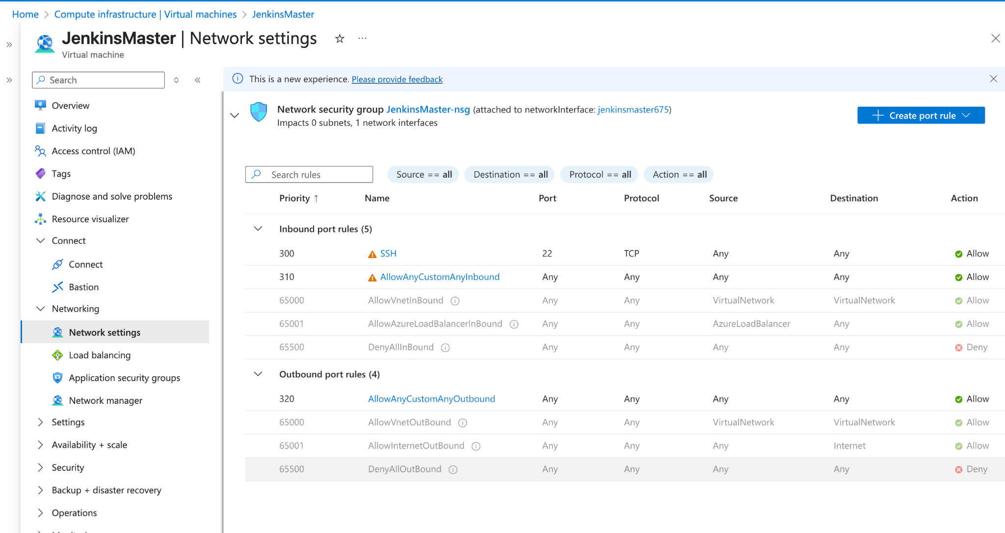

root@JenkinsMaster:~# sudo cat /var/lib/jenkins/secrets/initialAdminPassword
f0ae3cdb952c4ec89f6d6b6b0e97f133
root@JenkinsMaster:~#
